PRELIMINARY PROGRAM
Workshop/Training Course
‘Pulsation and Vibration Control in Process Installations’
TNO Delft, 8-9 April, 2024

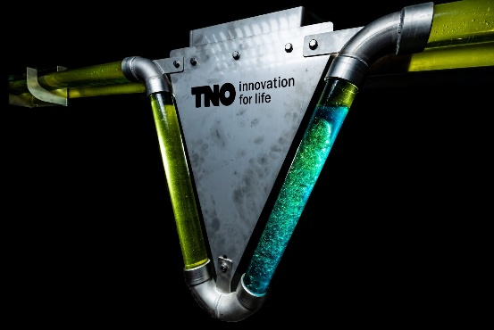
Monday April 8

Plenary

08.30 – 09.00 Welcome coffee
09.00 – 09.15 Introduction to TNO/PVC course
09.15 – 10.15 Pulsation and Vibration effects in Process Installation
10.15 – 10.30 Coffee break
10.30 – 11.30 Fundamentals of wave propagation in piping
11.30 – 12.00 Fundamentals of mechanical response analysis

12.00 – 13.00 Lunch buffet

Parallel sessions

Positive displacement machinery
13.00 – 14.15 Pulsations in Reciprocating Compressor
14.15 – 14.30 Break
14.30 – 15.30 Pulsations in Reciprocating Pump systems
15.30 – 15.45 Break
15.45 – 16.15 Pulsations in screw compressors (Rens)
16.15 – 17.00 Application to Hydrogen compression systems

Flow induced pulsations/vibrations
13.00 – 14.00 Water hammer
14.00 – 14.45 Pulsations in turbo compressor systems
14.45 – 15.00 Tea break
15.00 – 15.45 Flow induced Pulsations
15.45 – 17.00 Multiphase forcing

Plenary
19.00 – 22.00 Dinner in the city centre of Delft.

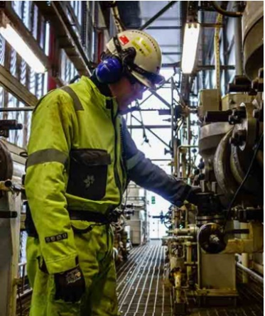

Tuesday April 9

Plenary

08.30 – 09.00 Welcome coffee
09.00 – 10.00 Introduction to pipe vibrations
10.00 – 10.15 Coffee break
10.15 – 11.15 Measuring pulsations and vibrations
11.15 – 12.15 Introduction to fatigue

12.15 – 13.15 Lunch buffet

Parallel sessions

Positive displacement machinery
13.15 – 14.00 API Workflow, Acoustics
14.00 – 14.45 API Workflow, Mechanics
14.45 – 15.00 Tea break
15.00 – 16.30 API Workflow, Case Study

Flow induced pulsations/vibrations
13.15 – 14.45 AVIFF Workflow, guidelines
14.45 – 15.00 Tea break
15.00 – 16.30 AVIFF Workflow, Case Study

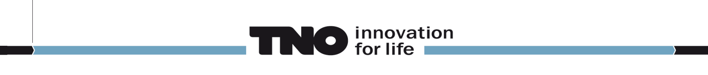
PRESENTERS LIST
Workshop/Training Course
‘Pulsation and Vibration Control in Process Installations’
TNO Delft, 8-9 April, 2024

Stefan Belfroid
Studied applied physics at the Technical University of Eindhoven. After 4 years at Stork Product Engineering now works for over 20 years as senior scientist for TNO on topics on Flow-Induced Pulsations and Dynamic Multiphase Flow. His current interests are in CO2 storage and on the intersection of multiphase flow and pipe vibrations.

Leonard van Lier
Studied physics at the Technical University of Eindhoven. In his 20 year career at TNO, he specialized in Pulsations, Vibrations and Noise. In addition, he is taskforce leader of the Working Group Trainings, for the European Forum for Reciprocating Compressors (EFRC).

Pieter van Beek
Technical Lead on Fluid Dynamics, Acoustics and Asset Integrity at TNO. More than 20 years of experience in contract research, consultancy and Root Cause Analysis (RCA) on pulsation, vibration & noise and mechanical integrity of rotating & reciprocating equipment and adjacent process installations.

Rens Bazuin
Specialist in the field of pulsation and vibration control. Involved in both field measurements and numerical simulations. Lead developer of the acoustic part of the TNO simulation tool Pulsim.

Néstor González Díez
Senior project leader with a focus on questions connected to flow-induced vibration and turbomachinery in the energy infrastructure.

Wilbert Vink
Pulsations and Vibration consultant for positive displacement machines in accordance with API-618/619/674 standards, with 15 years of experience in this field. Responsible for Pulsim software development, support, training and sales.

Lennert Buijs
Project manager and program manager for Energy Infrastructure Integrity studies within TNO Energy Transition. Over 10 years of experience as consultant in projects related to fluid structure interaction related, API compliance studies and process dynamics.

Swen Konings
Conducts technical consultancy work at the Heat Transfer and Fluid Dynamics department. Specialist on pulsation and vibration control for positive displacement machines in accordance with API-618 and API-674 studies. Lead developer of the mechanical part of the TNO simulation tool Pulsim.

